Rural Healthcare Power BI Dashboards README

EXECUTIVE SUMMARY
Working with our IT professionals and Data department, I created dashboards for three related healthcare workforce programs. Querying an ORACLE relational database (CRM) with SQL, I retrieved individual participant data from multiple tables, exported to a .csv file. Querying financial information from a separate database, I created consolidated performance and spending reports. I created permissions for the appropriate team members to access the relevant dashboards, and pulled key visualizations for presentations and reports to management. My reports and dashboards represented the department’s shift in data analysis and visualization from Excel to Power BI, and the end of partners submitting individual reports with manually-entered data.

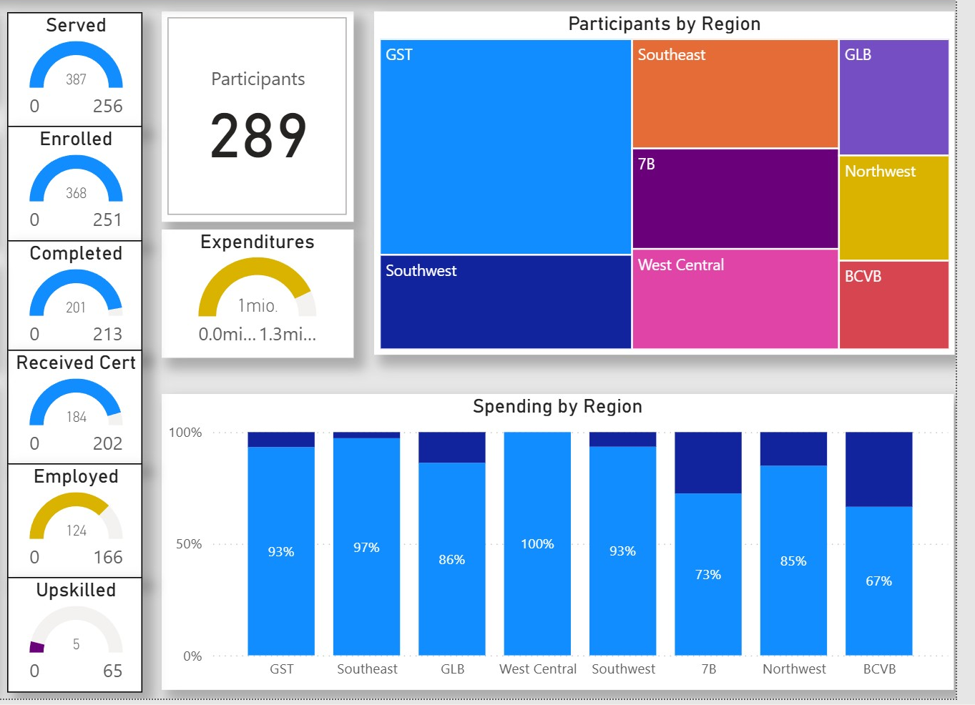
Figure 1: Program Overview dashboard for one of the rural healthcare workforce programs.
BACKGROUND
In February 2022, I joined the Michigan Department of Labor (MiDOL) to serve as data analyst and project manager for a healthcare workforce initiative. MiDOL disbursed funds from a federal healthcare workforce grant to Michigan workforce agencies (“MWAs”) that partnered with educational institutions to train Michigan residents for a select number of high-demand healthcare jobs. I was charged with holding strategy meetings with the workforce agencies, analyzing program progress, and creating reports for local, state, and national stakeholders.
When I began my work, all MiDOL program data was recorded and visualized through Microsoft Excel. Although I initially followed this practice with my Performance and Spending Tracking Tool, I wanted to move our department into the modern era of drawing data directly from a database, and using industry-standard BI tools.

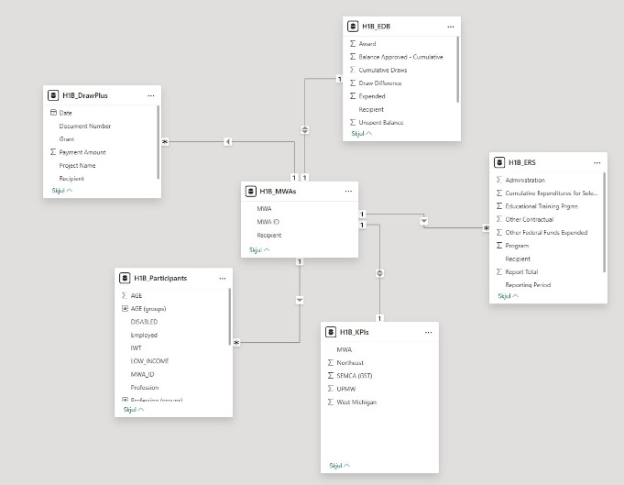
Figure 2: Star schema used to inform Power BI dashboards.

METHODS
MiDOL runs a CRM system that is accessed by the regional workforce agencies charged with maintaining participant (jobseeker) records. Until I implemented my Power BI data pipeline, our team had no access to this database and relied on quarterly excel files from the agencies, despite our direct access to the database. As the sole SQL-literate team member, I queried the relevant data to aggregate—as well as showing management all of the additional useful information to be gleaned from the CRM.
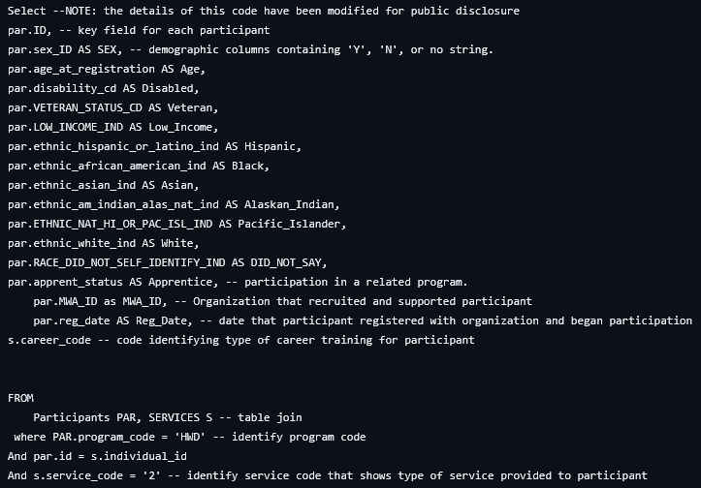
Figure 3: SQL code used to query data from Oracle database (statewide CRM system).

Based on the size of the data in question and the frequency of desired updates, I chose to extract the data to a .csv file at weekly intervals and update the Power BI files. Using a star schema, I cross analyzed key performance indicators with spending and demographic data.

Key Performance Indicators included:
- Number of participants (jobseekers) enrolled in the program.
- Number of participants who began training.
- Number of participants who completed training.
- Number of participants who earned an educational/training credential.
- Number of participants who earned a credential and found full-time, relevant work.
Key Spending Indicators included:
- Highest and lowest agency expenditures
- Total expenditures by quarter
- Spending by participant

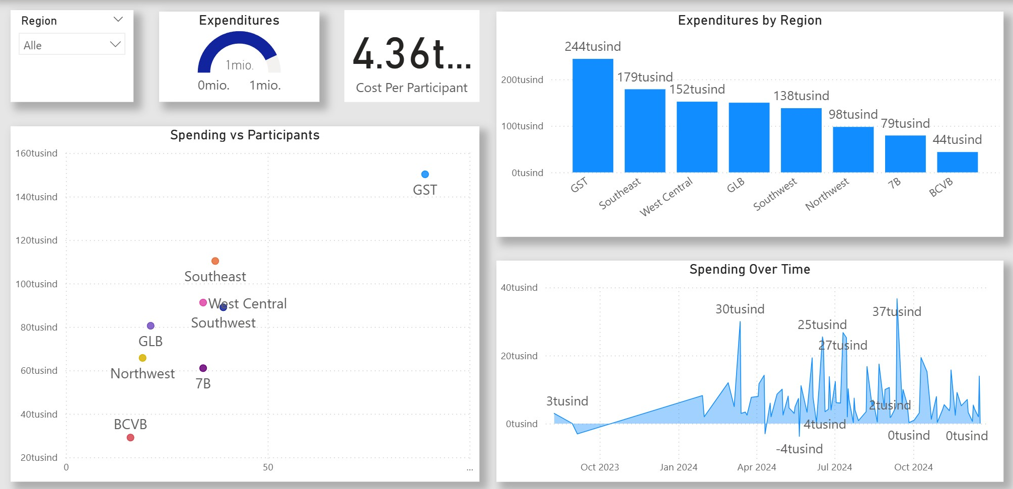
Figure 4: Financial dashboard for rural healthcare workforce program.

Key Demographic Data included:
- Rate of “underserved population” among participants (low income, disabled, veterans)
- Racial breakdown of each agency’s participants, relative to the racial breakdown of the region they served.
- Participant age, gender, profession they pursued in the program.

OUTCOMES
As a result of the Power BI data pipeline:
- funds were strategically re-allocated to the highest performing agencies, leading to a 12 percent increase in performance outcomes.
- regional agencies no longer had to “double enter” data, and MiDOL no longer had to “double analyze” the data, leading to reduced labor and fewer errors.
- We identified demographic performance gaps and met with agencies to create demographic-specific outreach programs to ensure equitable access.
- Agencies identified as efficient spenders were invited to share their best practices.

